TEACHERS’ PROGRAMME ON PREVENTION OF EARLY SCHOOL LEAVING
MAYO EDUCATION CENTRE

MODULE 3 – TEACHING METHODS

March 24th 2009

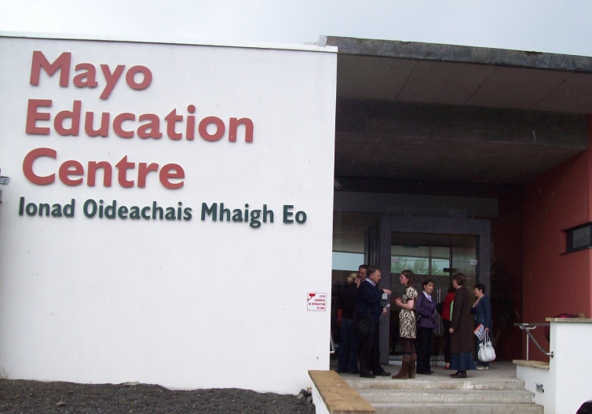

The session to explore Module 2 was conducted by Ann Caulfield and Art O Súilleabháin form Mayo Education Centre

PRESENT on the day were:

Ms Marie Verity
Ms Rosaleen Sullivan
Mr Daniel Forde
Mr Denis O’Boyle
Ms Josephine McDonagh
Ms Sarah Sheridan
Ms Philomena Browne

Discussion on Module 3, Teaching methods, was lively in Mayo. The module was considered to be comprehensive, well researched and raising very important points for consideration by teachers.

In its nature however, the module was thought to be tedious to read and reflect upon, being quite academic for the ordinary teacher. This has been documented by the participants on the Meeting Space. The concern was that it might lose the great wisdom therein if it was difficult to digest and needs several readings to ‘get it’. It was however considered that the module is very valuable and with some minor changes it will be more user friendly for teachers

In short...

STRENGTHS
The module has been well researched, is thorough and comprehensive
The techniques outlined enhance the learning for students at risk of early school leaving
The questionnaire on teaching styles is an excellent method of assessing teaching methods
The Peer Education and Co-operative Learning

WEAKNESSES
Quite wordy and needs to be read a few times. It is theoretical and the language difficult to comprehend for a once off sitting
Little reference to students and the issue of early school leaving -Little use of case studies and examples from schools

OPPORTUNITIES
Could have been laid out better and more concise

THREATS
The academic tendency of the module might prohibit teachers from investing time in it.
Consideration of school resources in integrating some of the tools outlined int he module

